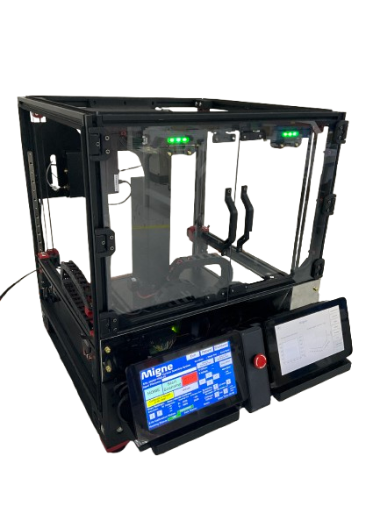
Migne Scanning System Operation Manual

Table of Contents
1. Knowing the System 3
2. Startup Procedure 6
3. Setup Procedure 9`
4. Scanning Procedure 11
5. Getting the Scan Data Results 14

1. Knowing the System
1.1 System Overview
- Monitor 1 displays the main system controls and operation interface.
- Monitor 2 displays the live scanning plot for foreign particle detection.
- The Emergency Button immediately stops all mechanical operations of the system.
- The Safety Door Sensor functions the same as the Emergency Button; when the door is open, the system will stop automatically.
- Door Status Indicator: Green: Door Closed, Red: Door Open.
  - Calibration & Scanning Areas
- The Calibration Area is used to calibrate the Z-Height of the scanning stage. This ensures that the distance between the sensor and the surface is set to the default 2.0 mm.
- The Scanning Area is where foreign particle detection is performed.

1.3 Scanning Stage
- The Scanning Stage is responsible for the movement during scanning detection.
- This is where the glass with particle is placed during scanning.
- The Calibration Jig is also mounted here when performing Z-Height calibration.

2. Startup Procedure
2.1 Stage Position Check
Ensure that the scanning stage is not inside the Shield Box.
If the stage is inside, pull the Y-Axis Frame until the stage is completely outside the Shield Box.

2.2 Y-Axis Frame Adjustment
Push down the Y-Axis Frame until it reaches the lowest position.
Make sure that all sides are level and even.

2.3 Power On
Turn ON the Power Switch and wait for the system to complete the boot-up process.

2.4 Emergency Button Check
Ensure that the Emergency Button is released before powering on.
The system will not operate if the Emergency Button is pressed until it is released

2.5 Homing
On the Monitor 1, press the HOME button
2.6 Homing Confirmation
Once finished homing, Homing Status will display “OK” and Axis Status will display “Home”.

3. Setup Procedure
3.1 Z-Height Calibration Position Offset
Press Go to Z-Ht Calibration Pos.
If no offset is indicated, set the offset using the arrow keys.
3.2 Calibration Jig Setup
After setting the Calibration Position offset:
- Press the HOME button.
- Place the Calibration Jig onto the scanning stage.
- Connect the Calibration Jig properly.

3.3 Z-Height Calibration
Press the Calibration button to calibrate the Z-Height of the scanning system.
3.4 Scanning Position Offset
After calibration:
- If the Scanning Position offset is not set, press Move to Scanning Pos.
- Adjust the offset using the arrow keys.
- Once set, perform Home positioning.
Note:
If X and Y offsets are set to 0, the stage will not move to their respective positions.

4. Scanning Procedure
4.1 Homing Check
Perform Home positioning if the Home Status is not currently set to HOME.
4.2 Test Mode Selection
Ensure that the Single Test Option is selected.

4.3 Sample Placement
Place the glass with particle onto the scanning stage, then press Move to Scanning Pos.
4.4 Sample Alignment
Using the arrow keys:
- Center the glass and particle under the sensor.
- After adjustment, press the HOME button.

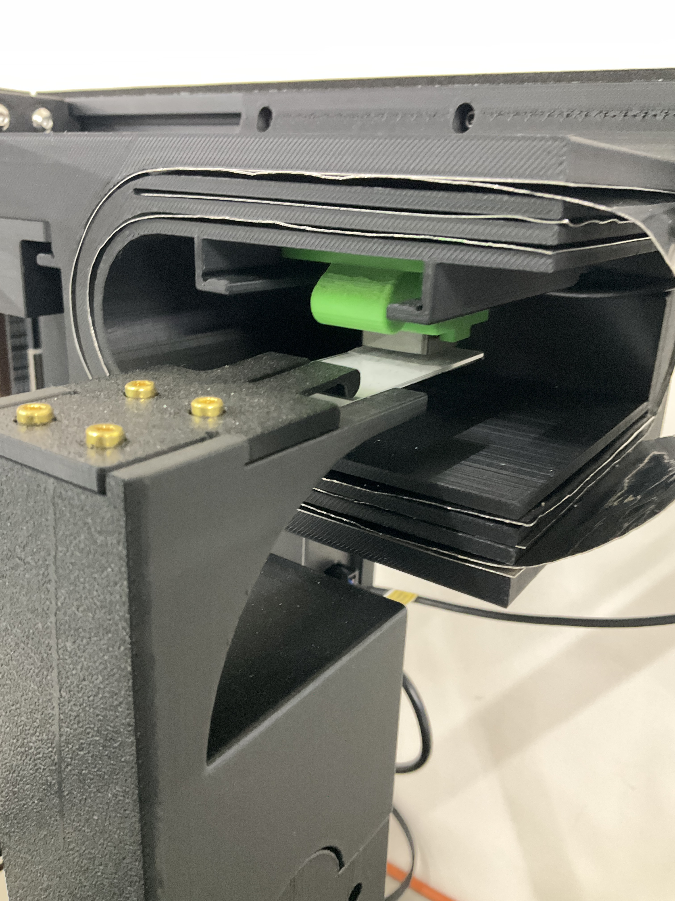
4.5 Scanning Parameters
- Select the desired scanning distance.
- Choose the scanning area from 20 × 20 mm up to 45 × 45 mm.
4.5 Start Scanning
Enter the desired filename in the Filename Input Box.
After confirming all parameters, press Start Scanning.

5. Getting the Scan Data Results
5.1 Displaying the Scan Detection Results:
- On Monitor 2, Press Load Raw File
- Input the filename you want to display on the Monitor 2
- After selecting, it will display the scan detection of the raw file you selected.

- In Live Scan, it will reset back the display from the loaded data

5.2 Downloading the Measurement Raw Data and Images Results:
- Connect a LAN cable between:
  - Monitor 2 Ethernet port
  - PC/Laptop Ethernet port
- On the PC, open Run and type:
- \\raspberrypi
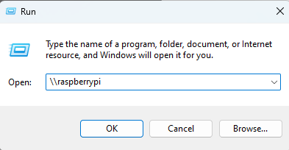
- Open the Shared folder for Scan Images

- Open the Shared/raw_data folder for raw data (Excel File).

- Copy and Paste it in your Pc/Laptop storage.

- Using the USB port, mount the flash drive
- Load the raw data you want to transfer, then click Save.
- It will directly transfer the raw data and its image display to the USB.

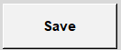

- After transferring, press Eject USB to unmount properly.
